When we run the nexaweb launcher, if you get the below exception in your user/.nexaweb/logs/xxx.log.
/**********************************************************************************/
javax.net.ssl.SSLHandshakeException: sun.security.validator.ValidatorException: PKIX path building failed: sun.security.provider.certpath.SunCertPathBuilderException:
unable to find valid certification path to requested target.
/**********************************************************************************/
Means you use the self-signed certificate, need to import the https certificate to java trust store.
- Export https certificate first.

Input your server address to browser (Chrome or others), for example, I input https://www.google.co.uk.

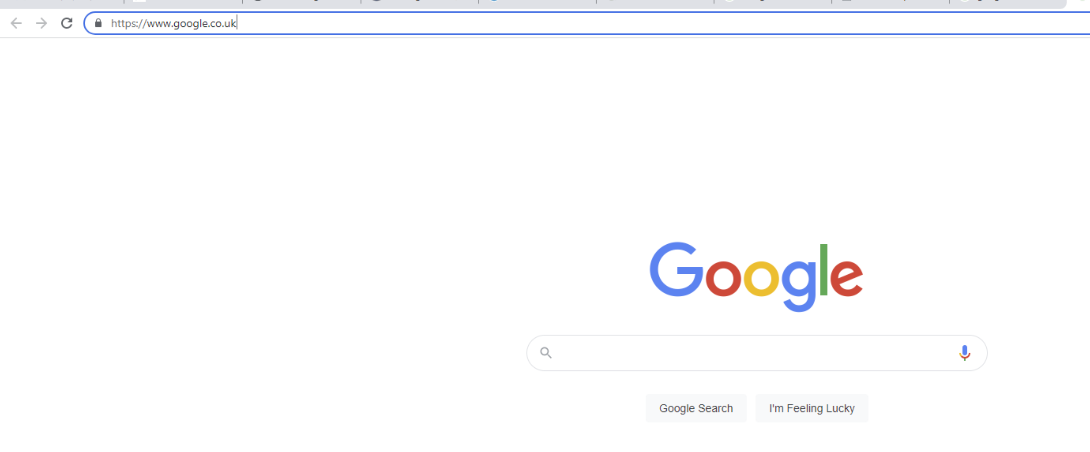

Click “lock” icon:
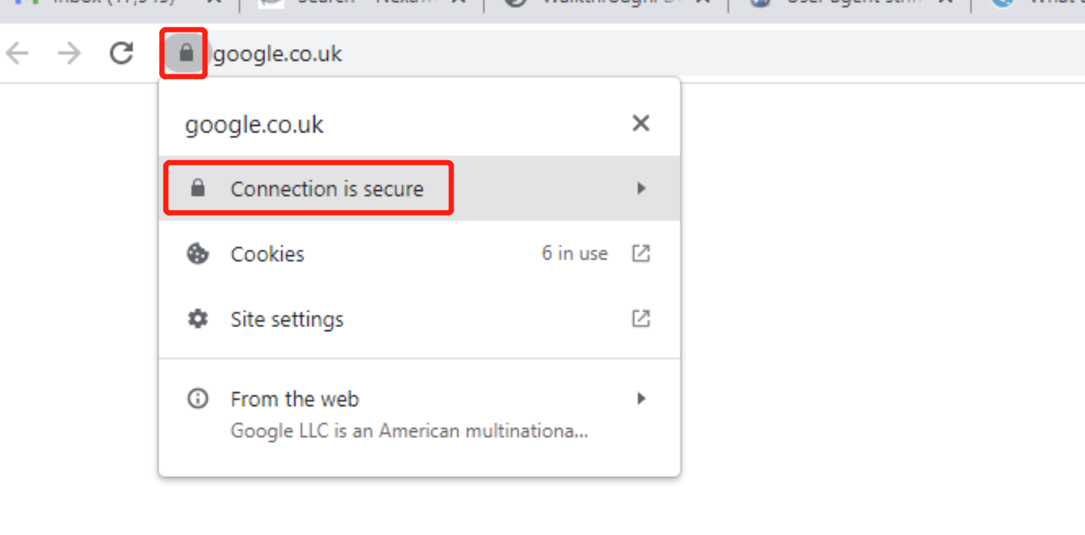
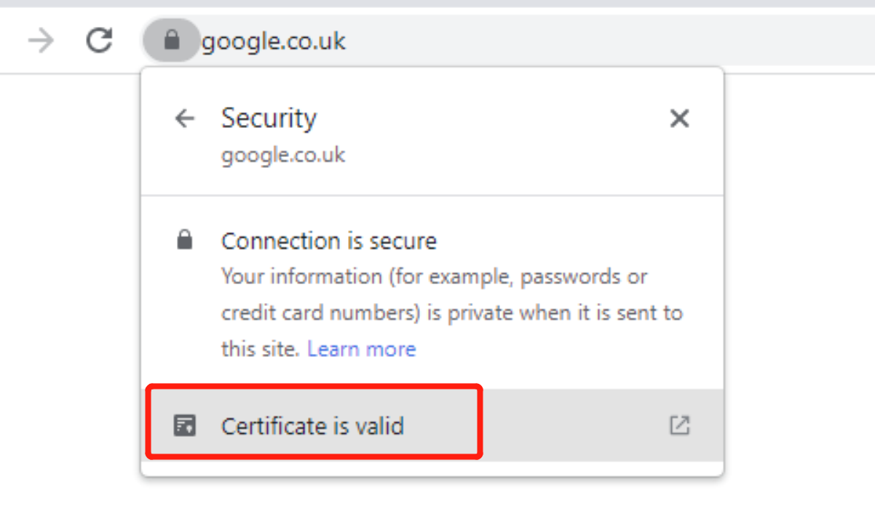
Click “Certificate is valid”, and “Details”, you can find “Export selected Certificate”.

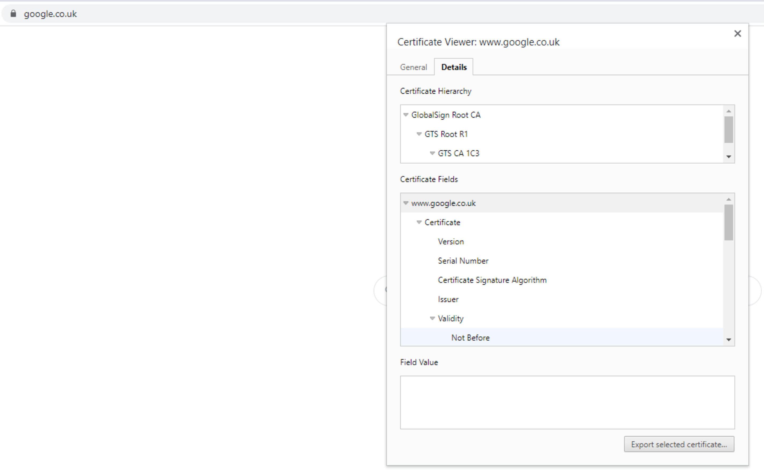

Export the certificate.

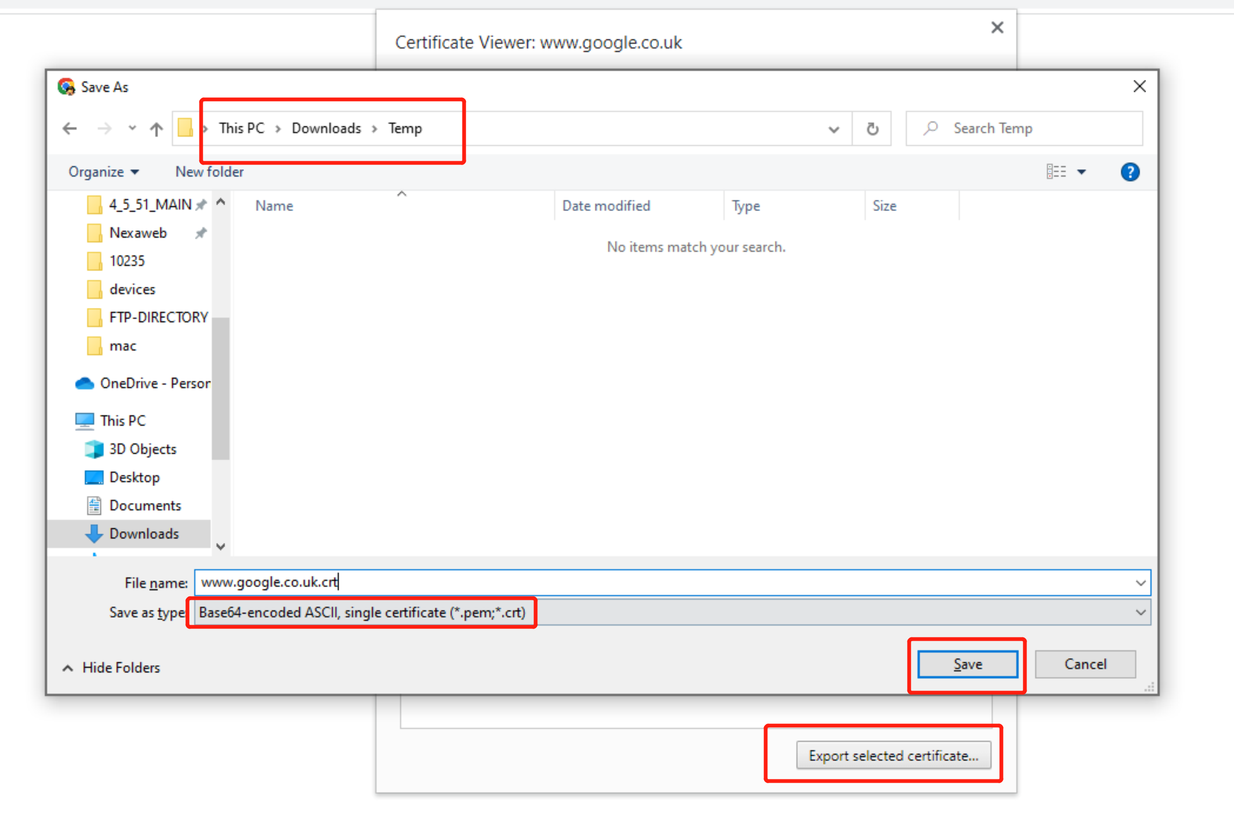

Go to the certificate file, we need to transfer .crt to .cer type. left menu -> Open with Internet Explorer.

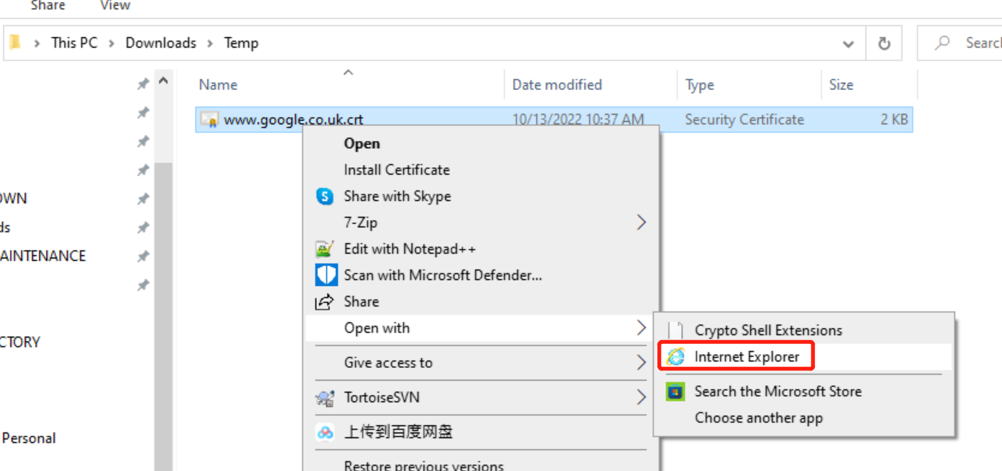

Open:

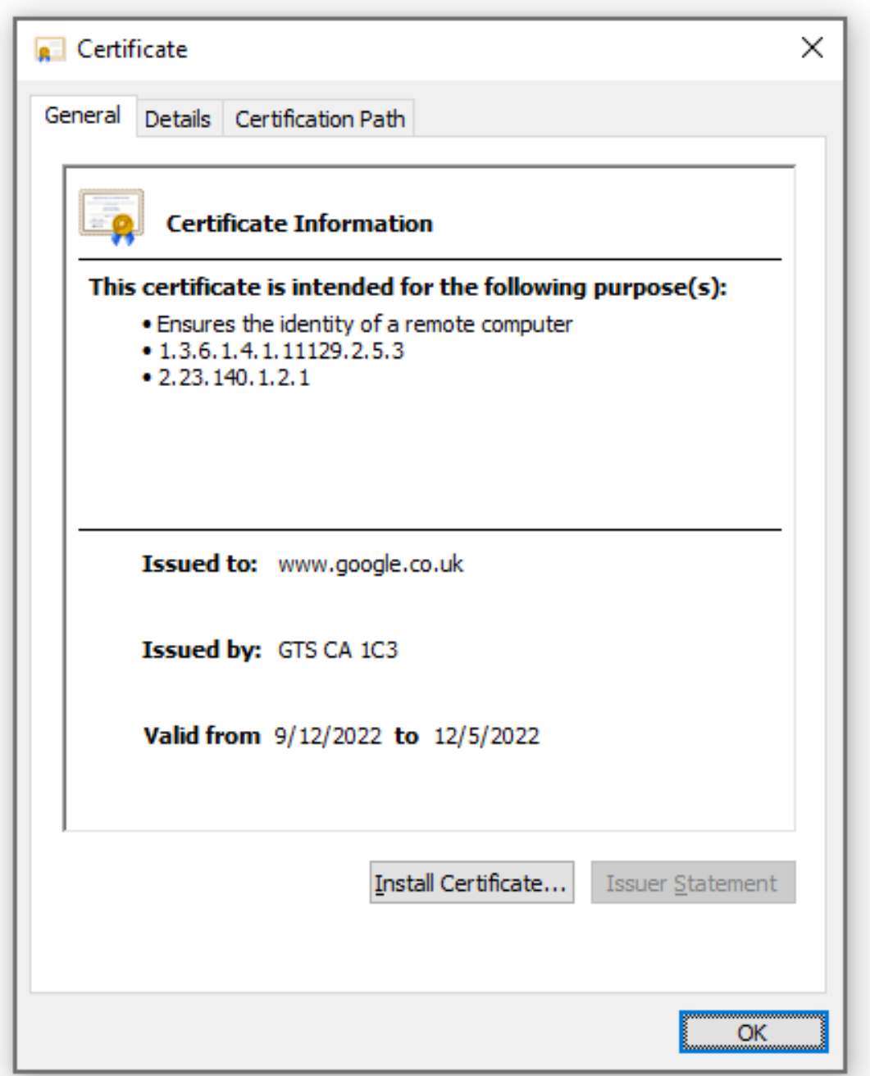

Details->Copy to File...

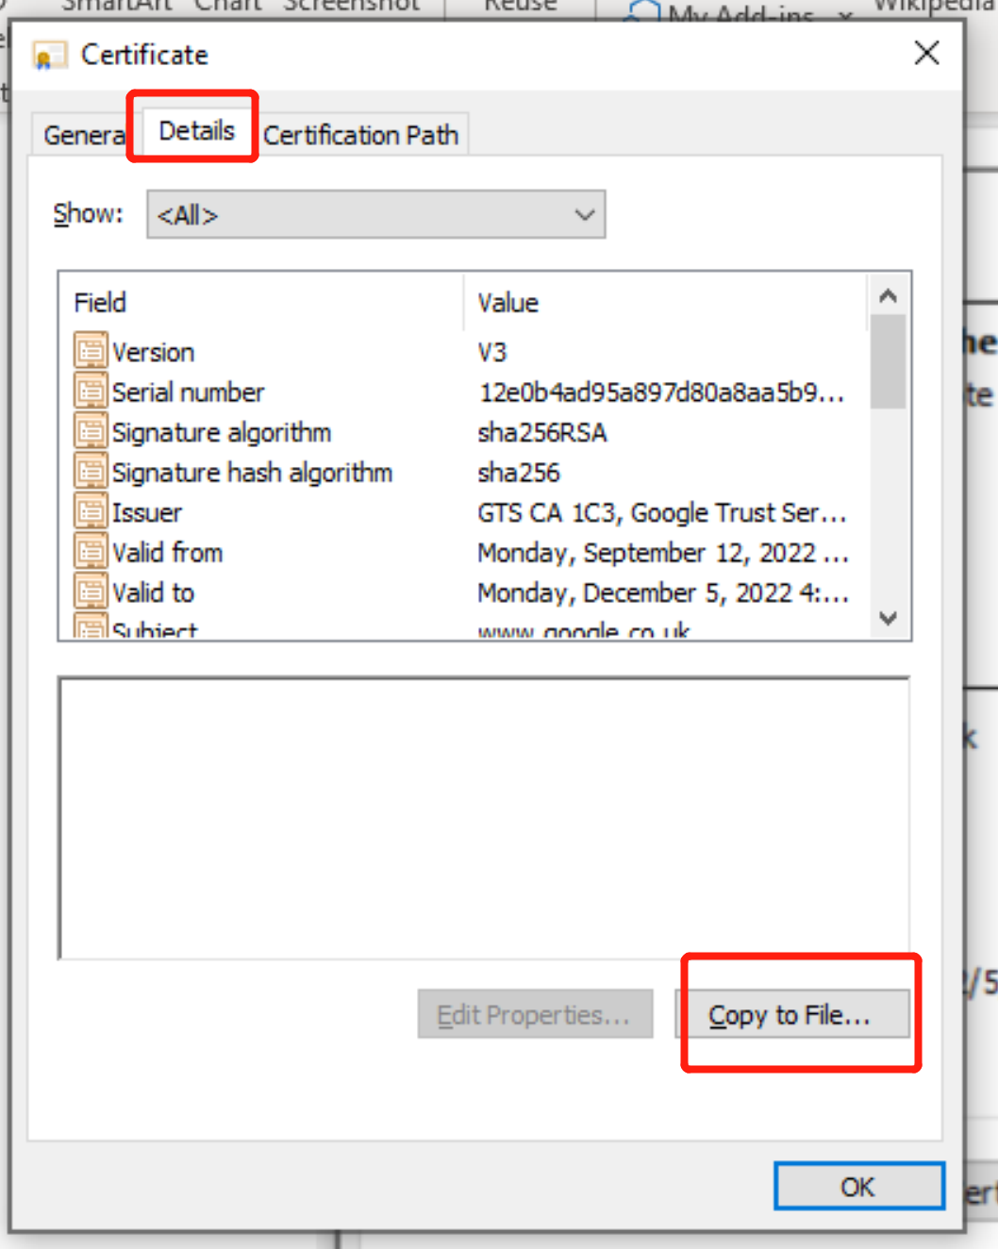

Export certificate as cert type:
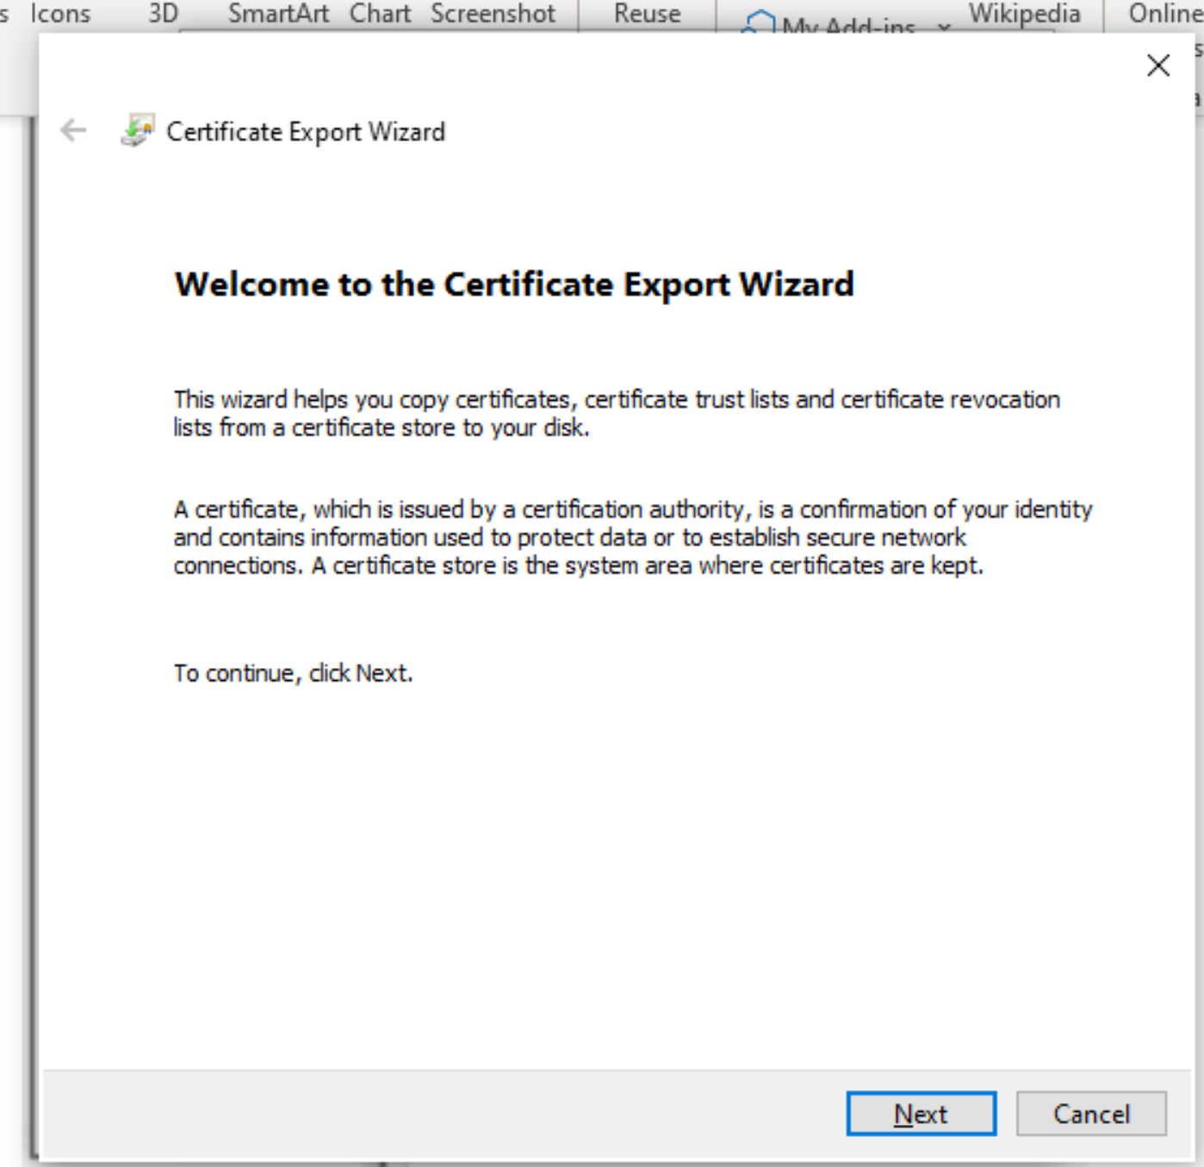

Select Base-64 encoded X.509(.CER) and Next.

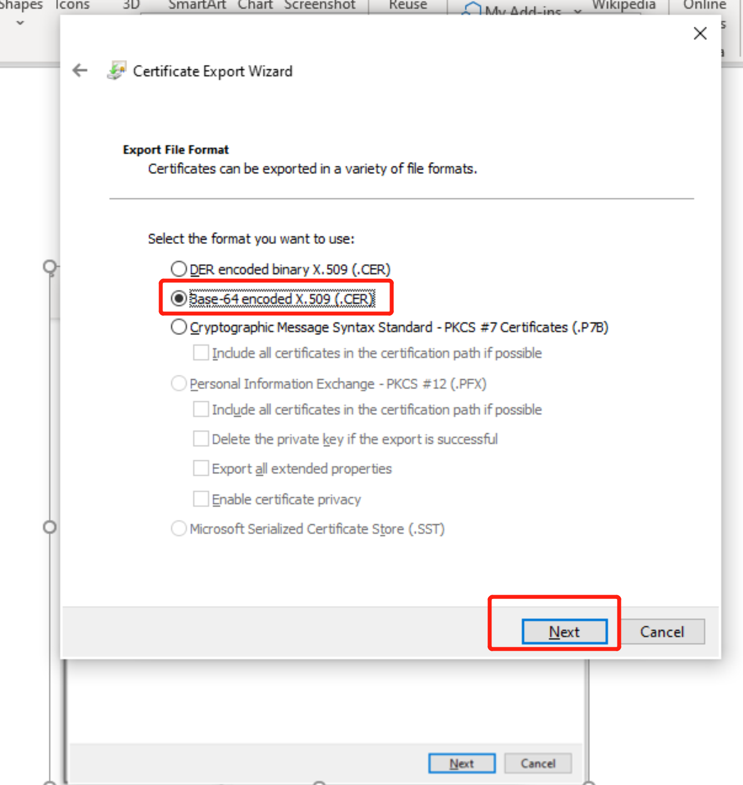

Save to your path:
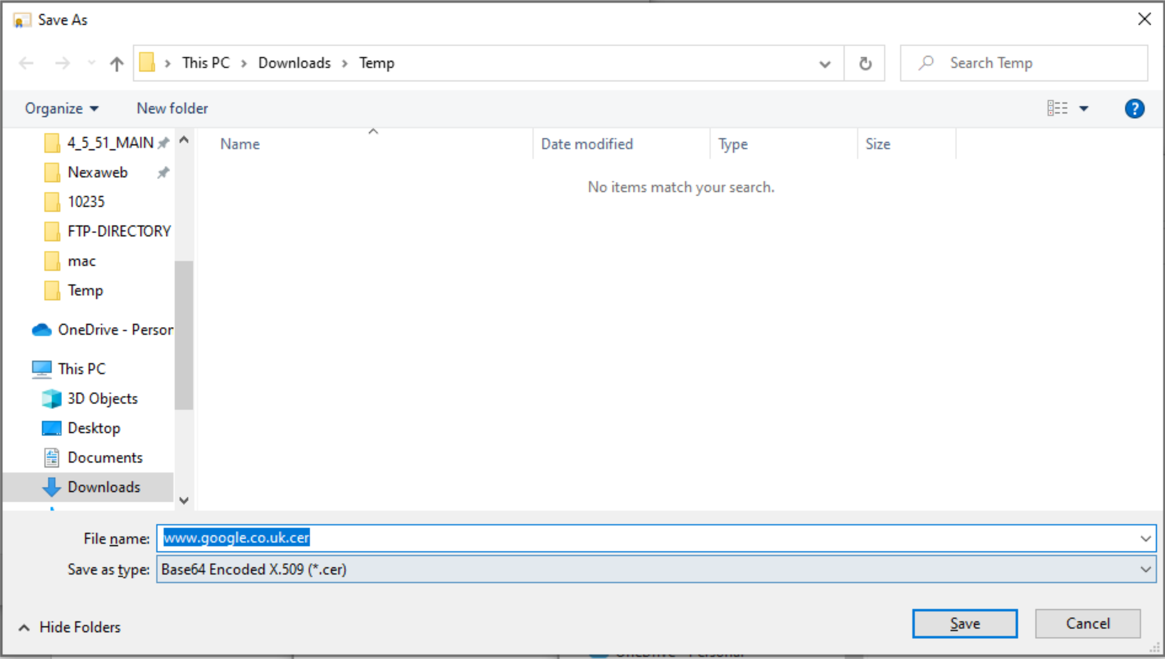

Finish, you will get the *.cer type certificate file:

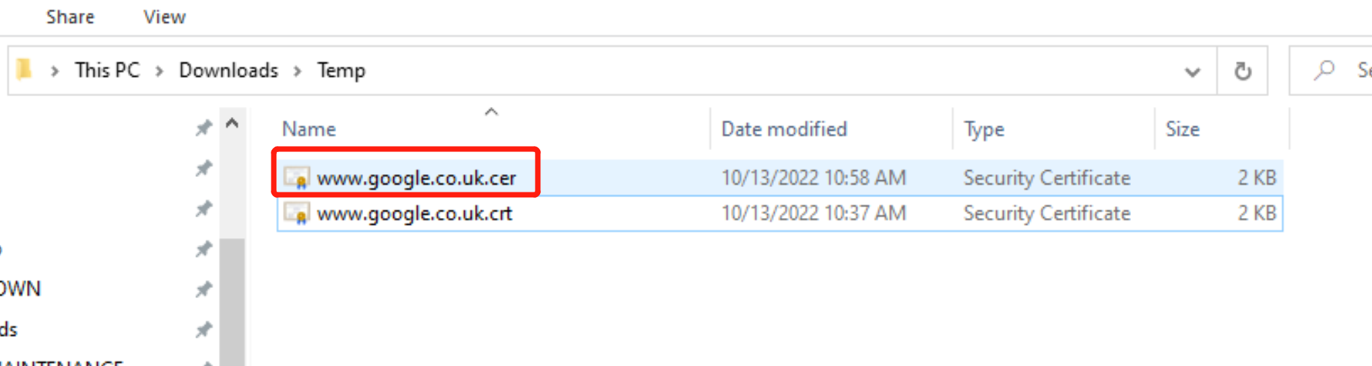

Go to command line and your jre\lib\security path.

Run the below command:
..\..\bin\keytool -import -trustcacerts -keystore cacerts -storepass changeit -noprompt -alias yourAliasName -file "C:\Users\dagzh\Downloads\Temp\www.google.co.uk.cer"

In my sample, since the certificate has exited, so it said alias already exists.

If you import your self-signed, you will get “Certificate was added to keystore”.

Go to file explore, cacerts has been updated, your self-sign certificate has been added, you can check modified date.
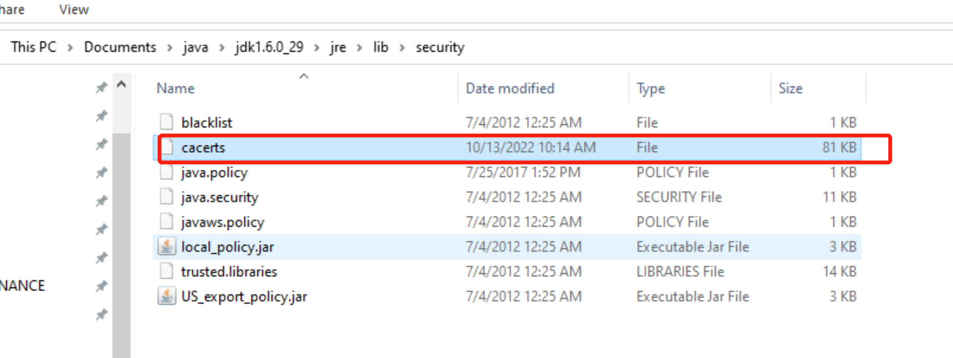

Copy this file to nexaweb launcher installed path\security\

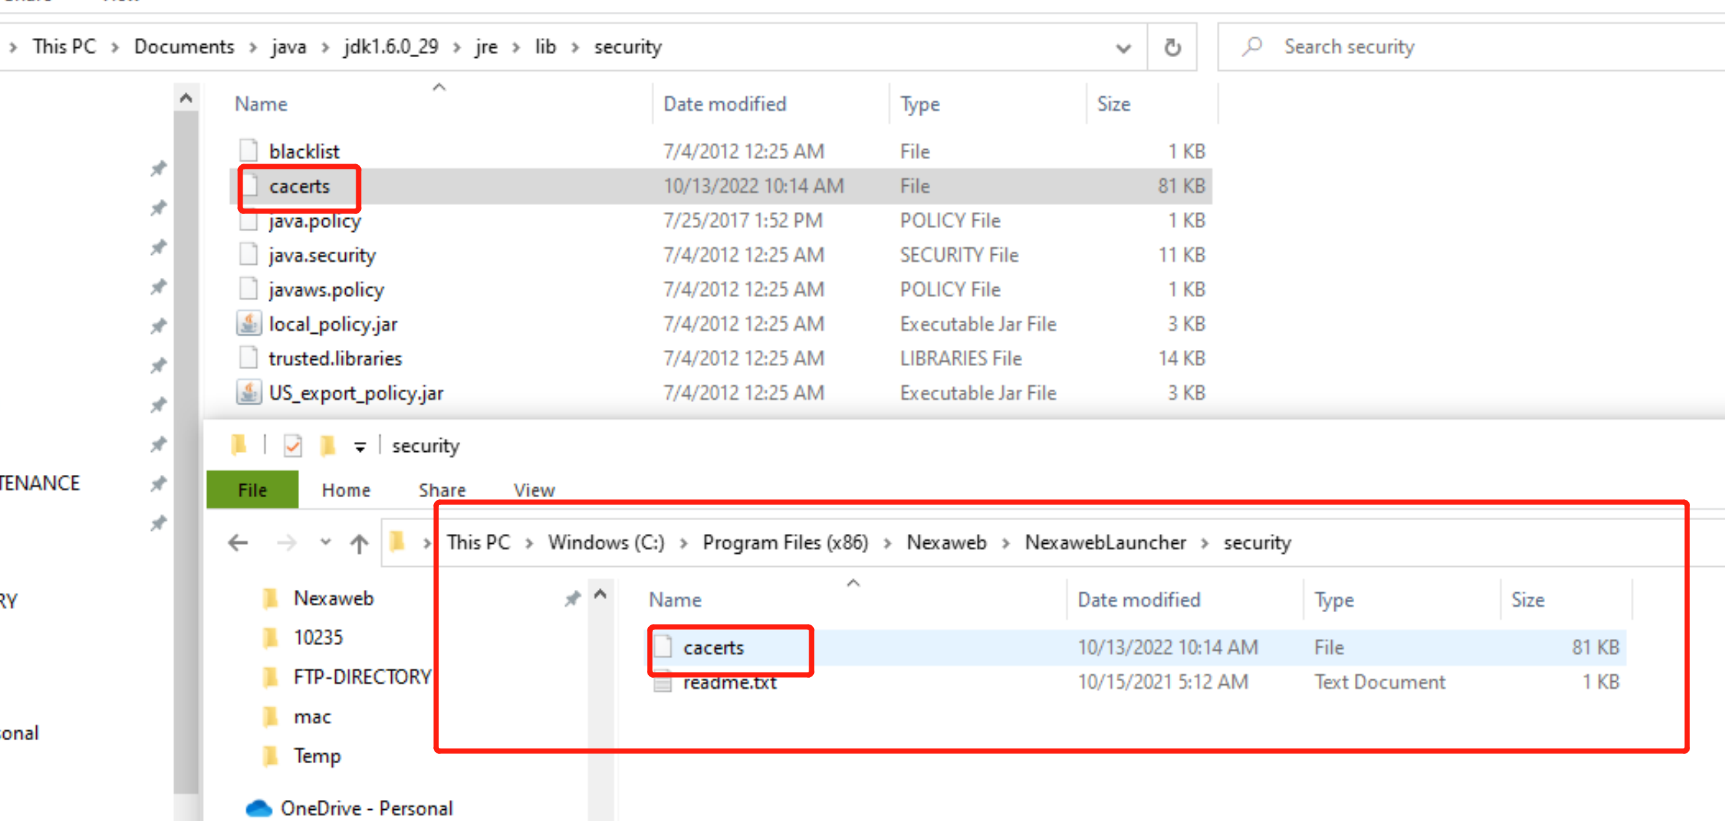
And add the below to runNexaweb.jsp in your project.
Just kind reminder, please add this line to screenshot position.
jvmarg =-Djavax.net.ssl.trustStore=C:\Program Files (x86)\Nexaweb\NexawebLauncher\security\cacerts

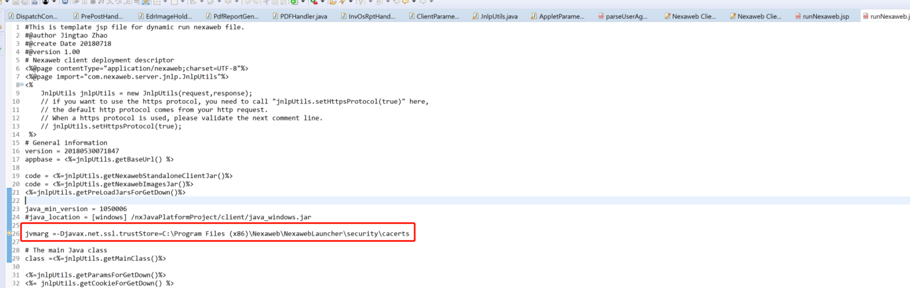

Run launcher again, good luck.

