The .nexaweb security signature
The nexaweb server will make a signature (RSA signature) to make sure what you get the .nexaweb file is not changed and generated by nexaweb server for every .nexaweb file which you get it from the browser and this file will be removed when the nexaweb application is closed.
For example:
You input the below url in the browser - http://localhost:8080/nxJava/runNexaweb.
The server will return back .nexaweb file and add one param “sign”, this param only be used by the launcher , it will be removed before start the nexaweb application.
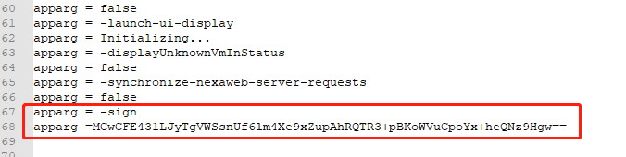
When you install the launcher, you will see the below dialog:
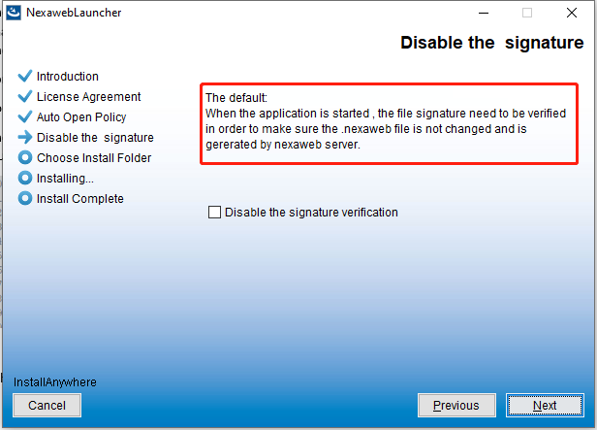

The default the disable signature verification is false, means the launcher will check .nexaweb signature is valid or not. We suggest you don’t disable the signature verification, it will protect .nexaweb file is not changed and is valid .nexaweb file.
If the signature verify fails, you will see the below error, and the nexaweb application is not started.
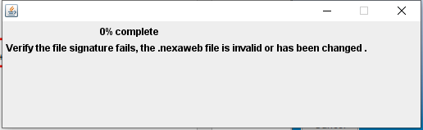

If you want to disable it (we don’t suggest), you can re-install the launcher or you can edit below configuration file.
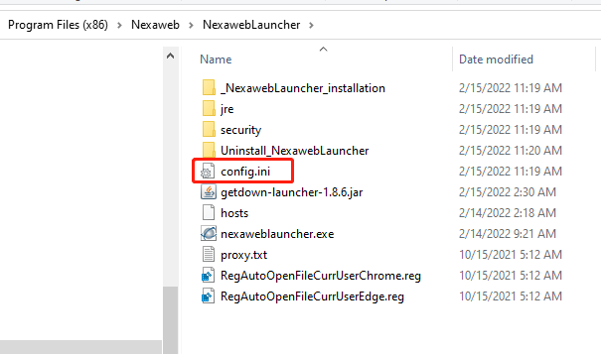

Please open and edit with notepad++ (or other tools, make sure the file is saved as UTF-8).
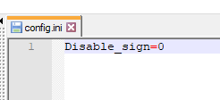

Disable_sign= 0, means check the signature.
Disable_sign=1, means doesn’t check the signature (we don’t suggest).

