How to enable whitelist
When you install Launcher, the “hosts” file will be installed to your installed path.
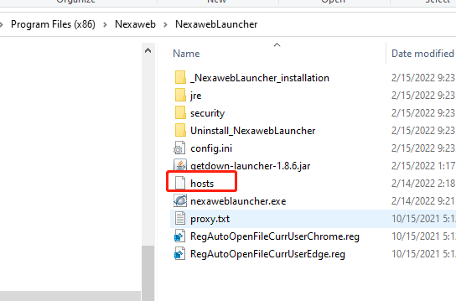

The default , the hosts file is empty, the white list feature is disable.
If you want to enable the white list feature, please open and edit this file with notepad++(you can use the other tools, make sure the file is saved with utf-8). Multiple values can be separated by commas

For example: localhost,*.nexaweb.com

If the host is not matched, you will get the below error , and the application can’t be started.
