The default. nexaweb file will be signed by integrated key, “com.nexaweb.server.util.GenerateSignKeyImpl”, you find it in the nexaweb-client.xml.

<launcher-config>
<sign_key-configuration>
<!--Class to provide sign key for .nexaweb. Replace with your own implementation,you can implement this interface com.nexaweb.util.GenerateSignKey in server. -->
<generate-key class="com.nexaweb.server.util.GenerateSignKeyImpl"/>
</sign_key-configuration>
</launcher-config>

If you want to use the yourself key, we need to implement the interface com.nexaweb.util.GenerateSignKey.

import com.nexaweb.server.util.GenerateSignKey;

public class KeySample implements GenerateSignKey {

public String getPrivateKey() {
// TODO Auto-generated method stub
return null;
}

public String getPublicKey() {
// TODO Auto-generated method stub
return null;
}

}
You can get the key from the database or file, we only show a plain.

You need a java 1.8 env and openssl (https://www.openssl.org/) , means can run keytool and openssl in command line.
You can replace red section with your organization, and use your password.
keytool -genkeypair -alias nexawebSec -keyalg DSA -keypass Nexaweb123 -sigalg SHA256withDSA -dname "cn=www.nexaweb.com,ou=nexaweb,o=nexaweb,l=burlington,st=MA,c=US" -validity 3650 -keystore nexawebKeystore.jks -keysize 1024 -storetype pkcs12 -storepass Nexaweb123

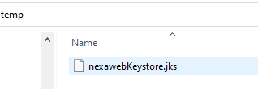

The file nexawebKeystore.jks will be generated.
You can run “keytool -list -v -keystore nexawebKeystore.jks” check your key, needs input your password.
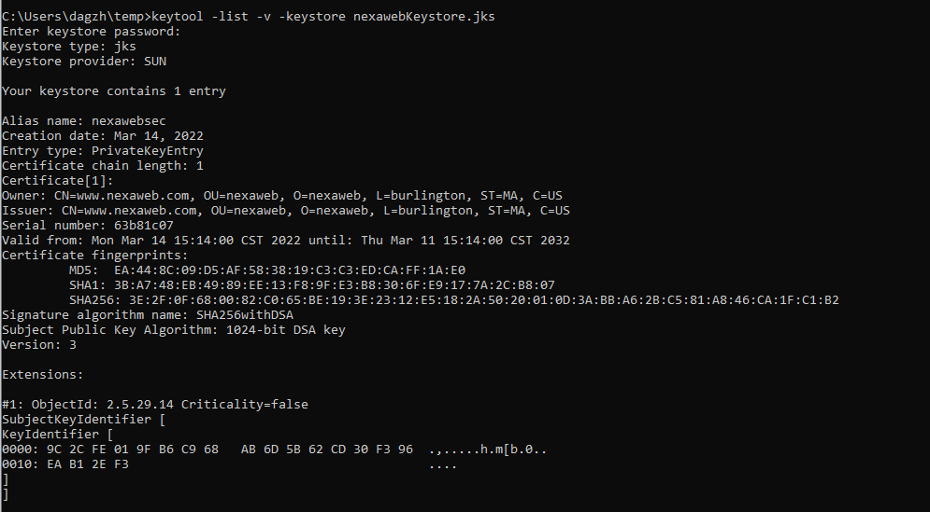

Get your public key:
keytool -export -alias nexawebSec -keystore nexawebKeystore.jks -rfc -file nexawebPublic.cert

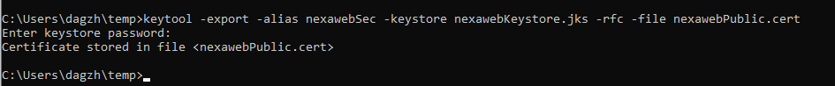
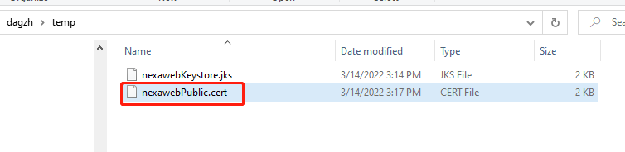

The public key file is generated , you can open it with notepad++.
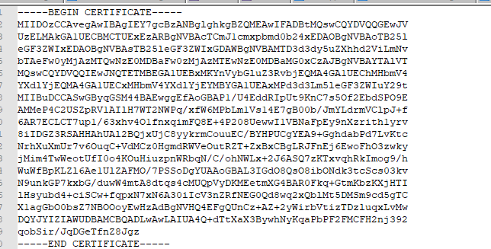

You can store this public key to your database or other sources.
We only copy this key to java.
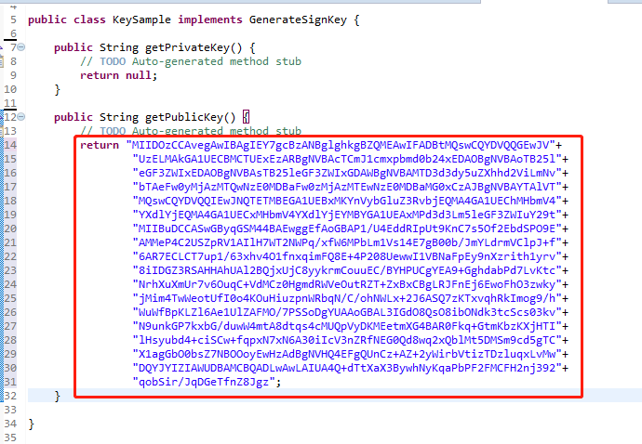

Get private key:

keytool -importkeystore -srckeystore nexawebKeystore.jks -destkeystore nexawebKeystore.p12 -deststoretype PKCS12

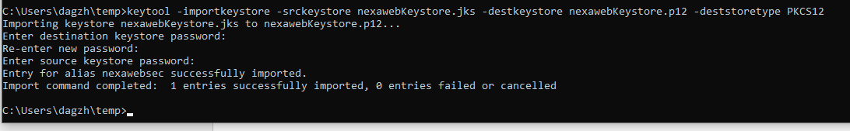

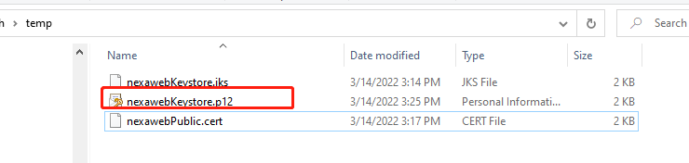

openssl pkcs12 -in nexawebKeystore.p12 -nodes -nocerts -out nexawebPrivate.pem

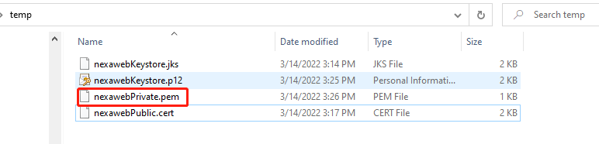

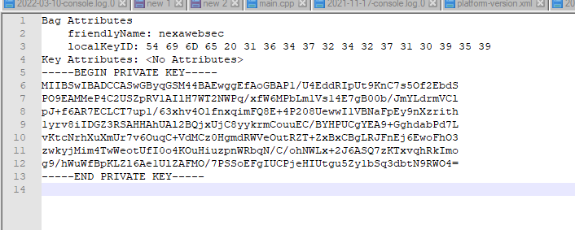

The private key is very important, please store it to safe position, and store them to your sources.
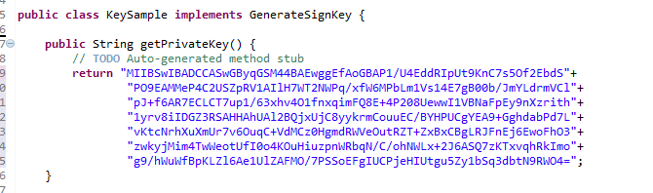

Please remove all files you have generated, and make sure they are removed from Recycle Bin.
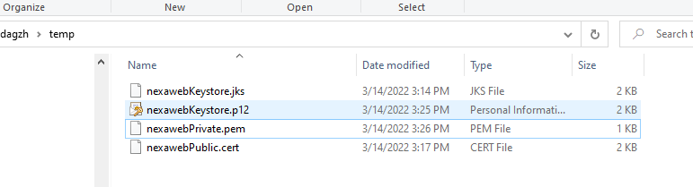

Replace the default key with your implementation.
<launcher-config>
<sign_key-configuration>
<!--Class to provide sign key for .nexaweb. Replace with your own implementation,you can implement this interface com.nexaweb.util.GenerateSignKey in server. -->
<generate-key class="signkey.impl.KeySample"/>
</sign_key-configuration>
</launcher-config>

Restart server.

